LIVE DASHBOARD

A Mini Project Report In
22CST52 - COMPUTER NETWORKS
Submitted by
SANTHOSH P -22CSR177
SANTHOSH S -22CSR178

SARAN AVINASH B -22CSR179

in partial fulfilment of the requirements for the award of the degree
of

BACHELOR OF ENGINEERING IN
COMPUTER SCIENCE AND ENGINEERING


KONGU ENGINEERING COLLEGE

(Autonomous)
PERUNDURAI ERODE-638060

NOVEMBER 2024

DEPARTMENT OF COMPUTER SCIENCE AND ENGINEERING KONGU ENGINEERING COLLEGE
(Autonomous) PERUNDURAI ERODE-638060 NOVEMBER 2024

BONAFIDE CERTIFICATE

This is to certify that the Project Report entitled LIVE DASHBOARD is the bonafide record of project work done by SANTHOSH P (Register no: 22CSR177), SANTHOSH S (Register no: 22CSR178), SARAN AVINASH B (Register no: 22CSR179 ) in partial fulfillment of the requirements for the award of the Degree of Bachelor of Engineering in Computer Science and Engineering of Anna University, Chennai during the year 2024-2025.

COURSE INSTRUCTOR HEAD OF THE DEPARTMENT

Date:

Submitted for the viva voce examination held on

TABLE OF CONTENTS

S.NO |  | TITLE
1 | PROJECT OBJECTIVE
2 | TECHNOLOGY STACK OVERVIEW
3 | FUNCTIONAL COMPONENTS  - FRONTEND DASHBOARD  - BACKEND SERVER  - POWERSHELL SCRIPT
4 | IMPLEMENTATION DETAILS
5 | KEY FEATURES  - REAL-TIME DATA STREAMING  - AUTOMATIC UPDATES  - RECONNECTION HANDLING
6 | CHALLENGES AND SOLUTIONS
7 | POTENTIAL ENHANCEMENTS
8 | CONCLUSION

Project Objective

The goal of this project is to create a Real-Time CPU Utilization Dashboard that monitors and visualizes system performance, particularly CPU usage, in real time. The application provides dynamic, live updates on CPU utilization trends, helping system administrators and users track performance metrics over time. The updates are delivered efficiently via WebSocket technology, ensuring seamless data transmission between the server and the client.

Overview of Technology Stack

- Frontend:
  - React: JavaScript library for building a responsive, dynamic user interface.
  - Chart.js with react-chartjs-2: Library for creating interactive line charts to display CPU utilization.
  - Socket.io Client: WebSocket-based client used to receive real-time data from the server.
- Backend:
  - Node.js with Express: Backend server to handle HTTP requests and WebSocket connections.
  - Socket.io Server: Enables real-time, bidirectional communication between the server and the client.
  - PowerShell Script: Gathers real-time CPU and memory data and sends it to the backend via HTTP POST requests.

Functional Components

- Frontend Dashboard:
  - CPU Utilization Chart: Displays real-time CPU usage as a line chart.
  - WebSocket Connection: Uses Socket.io to maintain a continuous connection with the server, receiving real-time updates without the need for frequent HTTP requests.
  - Data Handling and Formatting: Receives raw data, formats it for Chart.js, and automatically updates the chart with new data.

- Backend Server:
  - CPU Data Collection: The server collects CPU utilization and available memory data from the system via PowerShell.
  - Data Broadcasting: The server broadcasts CPU data to all connected clients via Socket.io, allowing real-time updates.
  - WebSocket Setup: Establishes a WebSocket connection when a client connects and continuously emits updates at defined intervals.
- PowerShell Script:
  - Data Generation: A PowerShell script runs continuously, gathering CPU and memory data using Get-Counter and Get-CimInstance commands.
  - Data Sending: The script formats the data into a JSON object and sends it to the server's /api/cpuData endpoint every second, keeping the dashboard up-to-date.

Implementation Details

Frontend Code (React):
- WebSocket Connection:
  - Established inside a useEffect hook that runs once when the component mounts.
  - Listens for cpuData events from the server and updates the chart with the new data.
- Chart Configuration:
  - Uses the Line component from react-chartjs-2, which is dynamically updated each time new data is received.
  - The chart uses timestamps as labels and CPU utilization percentages as data points.
- Real-Time Data Handling:
  - As the data is received from the server, it automatically updates the state, causing the component to re-render with the latest data.
  - The options for the chart are configured to ensure that the y-axis begins at zero and the maximum value is 100%.

Backend Code (Node.js and Express):
- Setting Up Socket.io:
  - Initializes Socket.io alongside the Express server, allowing real-time communication with clients.
  - The server listens for incoming client connections and emits CPU utilization data to all connected clients.
- CPU Data Collection and Broadcasting:
  - The server's /api/cpuData endpoint receives data from the PowerShell script, formats it, and broadcasts it to all clients via Socket.io.
  - The server also sends the latest data to new clients when they first connect.

PowerShell Script:
- Data Collection:
  - The script collects CPU and memory data every second using the following commands:
    - Get-Counter '\Processor(_Total)\% Processor Time' for CPU utilization.
    - Get-Counter '\Memory\Available MBytes' for available memory.
    - Get-CimInstance Win32_PhysicalMemory to calculate the total RAM.

- Data Formatting and Sending:
  - The data is formatted into a JSON object and sent to the backend's /api/cpuData endpoint via an HTTP POST request every second.

Powershell

$totalRam = (Get-CimInstance Win32_PhysicalMemory | Measure-Object -Property capacity -Sum).Sum
while($true) {
$date = Get-Date -Format "yyyy-MM-dd HH:mm:ss"
$cpuTime = (Get-Counter '\Processor(_Total)\% Processor Time').CounterSamples.CookedValue
$availMem = (Get-Counter '\Memory\Available MBytes').CounterSamples.CookedValue
$date + ' > CPU: ' + $cpuTime.ToString("#,0.000") + '%, Avail. Mem.: ' + $availMem.ToString("N0") + 'MB (' + (104857600 * $availMem / $totalRam).ToString("#,0.0") + '%)'

$JSON = @{
"date" = $date
"cpu" = $cpuTime
"memory" = $availMem
} | ConvertTo-Json

Invoke-WebRequest -Uri "http://localhost:8080/api/cpuData" -Method Post -Body $JSON -ContentType "application/json"
Start-Sleep -s 1
}

Key Features and Workflow

- Real-Time Data Streaming:
  - The server collects CPU and memory data at regular intervals and broadcasts this information to all connected clients.
  - Each client listens for updates and visualizes the data in real-time without manual refreshes.
- Automatic Data Updates:
  - Data is pushed from the server to the client in real-time, maintaining an up-to-date chart for the user.
- Disconnection and Reconnection:
  - If a client disconnects, Socket.io automatically attempts to reconnect, ensuring continuous data flow.

Challenges and Solutions

- Real-Time Data Handling:
  - Challenge: Ensuring smooth, efficient data flow without overwhelming the client or server.
  - Solution: WebSocket technology ensures low-latency, bidirectional communication, and the frontend handles only a limited set of recent data points to conserve memory.
- Data Synchronization:
  - Challenge: Keeping all connected clients synchronized with the latest data.
  - Solution: The server broadcasts data to all connected clients simultaneously, ensuring consistent updates across all users.

- Connection Management:
  - Challenge: Handling disconnections and ensuring the connection remains stable.
  - Solution: Socket.io's automatic reconnection feature ensures reliable communication even in the case of temporary disconnections.

Potential Enhancements

- Database Integration:
  - Store historical CPU and memory data in a database (e.g., MongoDB) to allow users to view performance trends over time.
- Additional System Metrics:
  - Expand the dashboard to include other system metrics, such as disk usage, network usage, and temperature, to offer a more comprehensive system monitoring tool.
- User-Configurable Refresh Rates:
  - Allow users to adjust the data refresh rate to balance real-time updates and network load.
- Enhanced UI/UX:
  - Improve the design with smoother animations, additional customization options, and a responsive layout for better user experience.

CODE
Server.js

const express = require("express");
const http = require("http");
const socketIo = require("socket.io");
const cors = require("cors");
const app = express();
const server = http.createServer(app);
const io = socketIo(server, {
cors: {
origin: "http://localhost:3000",
methods: ["GET", "POST"],
},
});
const PORT = 8080;
app.use(cors());
app.use(express.json());
let data = {
labels: [],
datasets: [
{
label: "CPU Utilization (%)",
data: [],
borderColor: "red",
borderWidth: 2,
},
],
};

app.post("/api/cpuData", (req, res) => {
const { date, cpu, memory } = req.body;
data.labels.push(date.split(" ")[1]);
data.datasets[0].data.push(cpu.toFixed(2));
io.emit("cpuData", data);
res.status(200).json({ message: "Data received and broadcasted" });
});

app.get("/cpuData", (req, res) => {
res.json(data);
});

server.listen(PORT, () => {
console.log(`Server listening on port ${PORT}`);
});

Dashboard.js

import React, { useEffect, useState } from 'react';
import { Line } from 'react-chartjs-2';
import {
Chart as ChartJS,
CategoryScale,
LinearScale,
PointElement,
LineElement,
Title,
Tooltip,
Legend,
} from 'chart.js';
import { io } from 'socket.io-client'; // Importing socket.io-client

// Register necessary Chart.js components
ChartJS.register(
CategoryScale,
LinearScale,
PointElement,
LineElement,
Title,
Tooltip,
Legend
);

function Dashboard() {
const [data, setData] = useState({
labels: [],
datasets: [
{
label: 'CPU Utilization (%)',
data: [],
borderColor: 'red',
borderWidth: 2,
},
],
});

useEffect(() => {
const socket = io('http://localhost:8080');
socket.on('cpuData', (cpuData) => {
setData(cpuData);
});
return () => {
socket.disconnect();
};
}, []);
const options = {
responsive: true,
scales: {
y: {
beginAtZero: true,
max: 100,
},
},
};
return (
<div className="container">
<h1>Real-time CPU Utilization</h1>
<div className="chart-container">
<Line data={data} options={options} />
</div>
</div>
);
}
export default Dashboard
Appendix

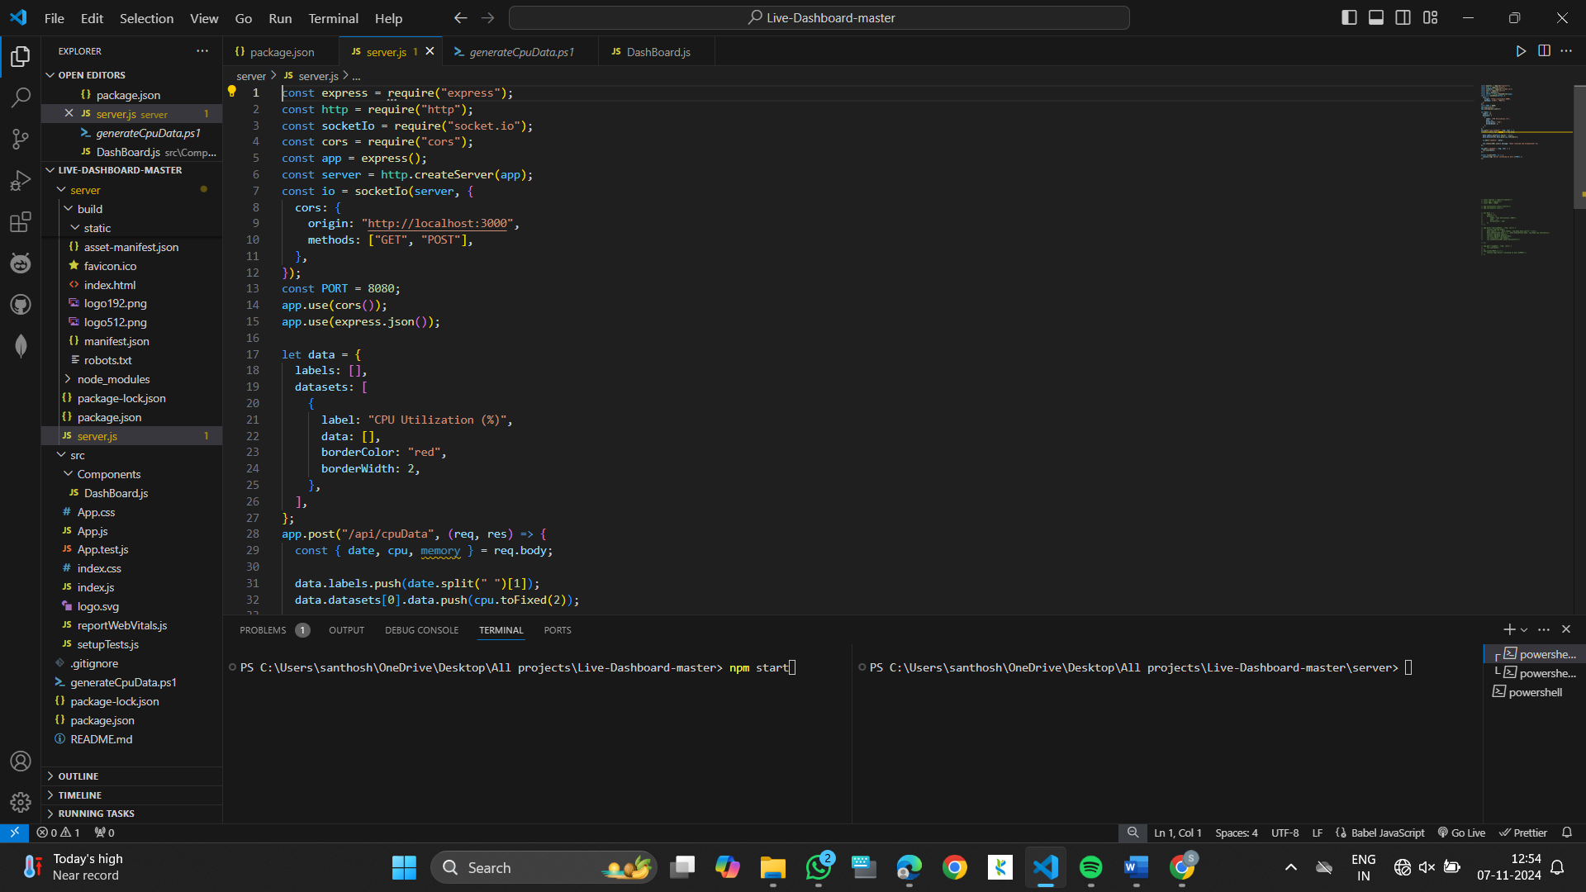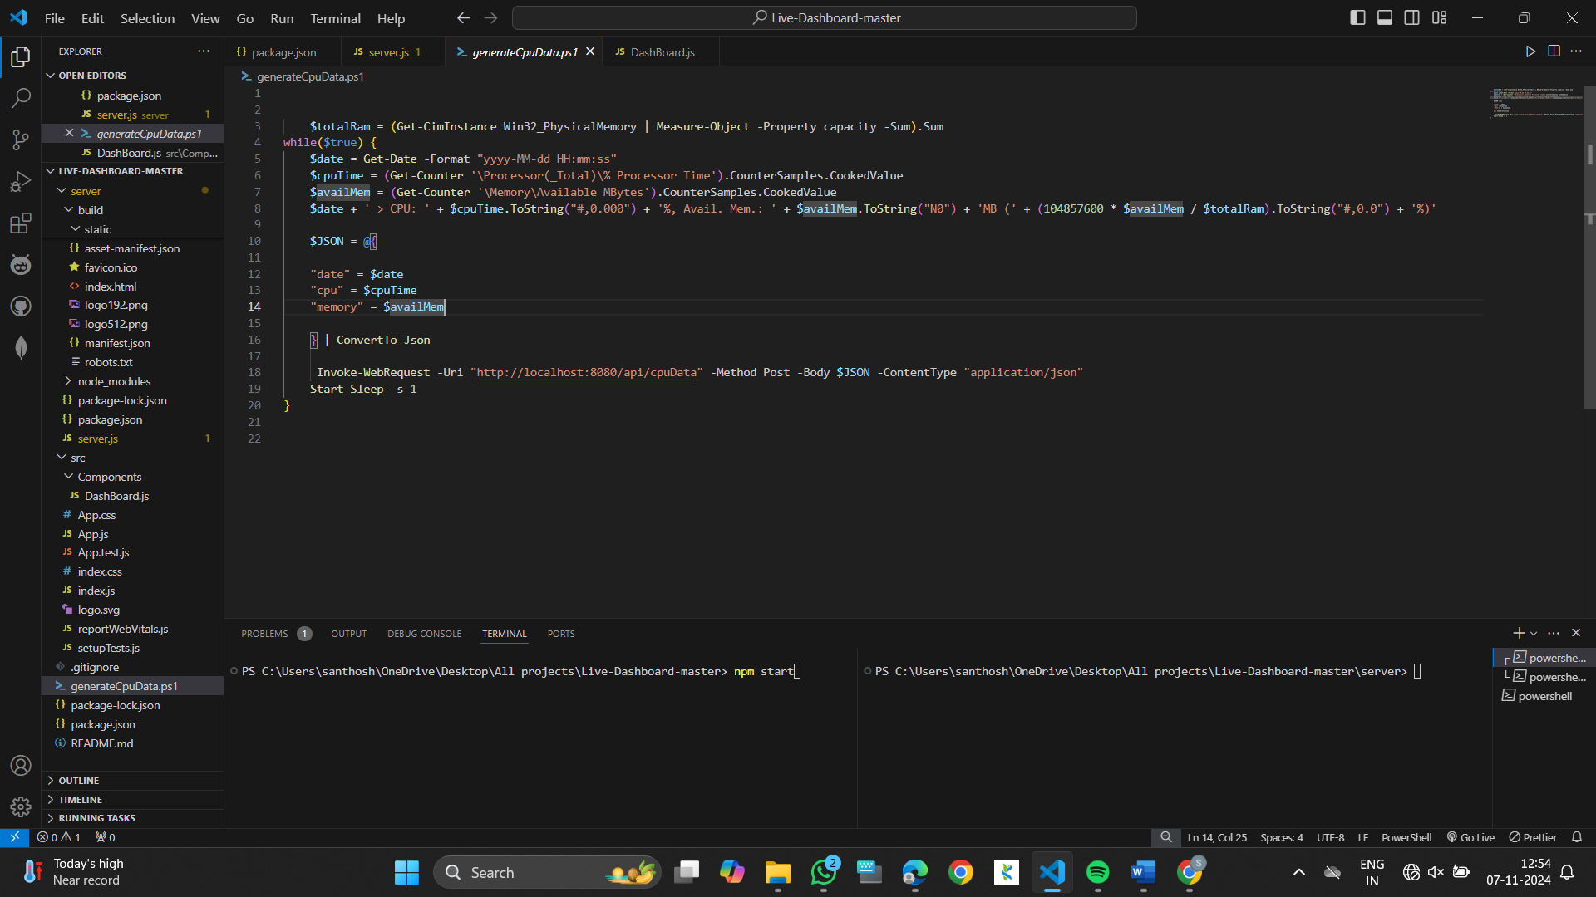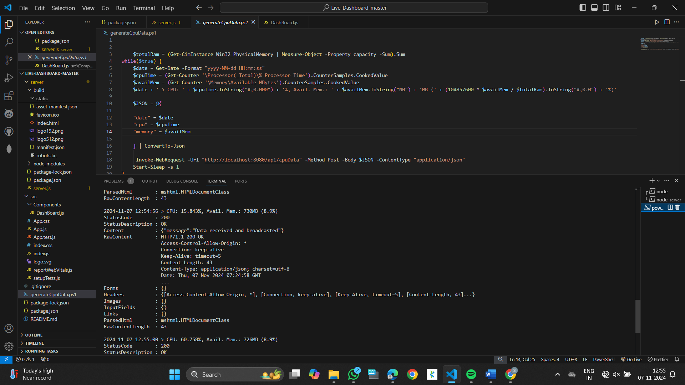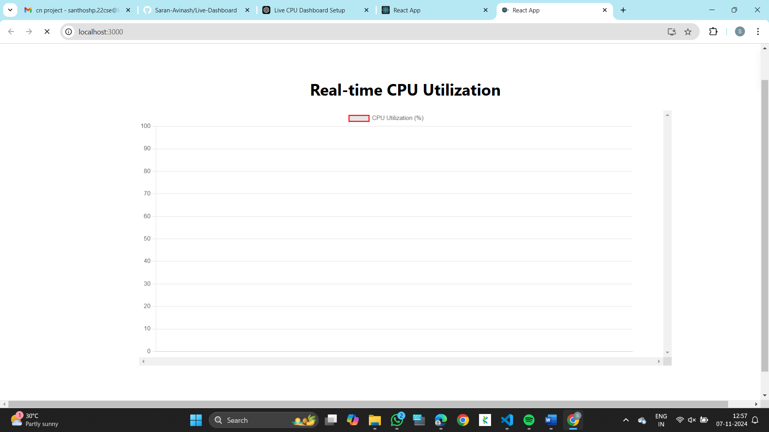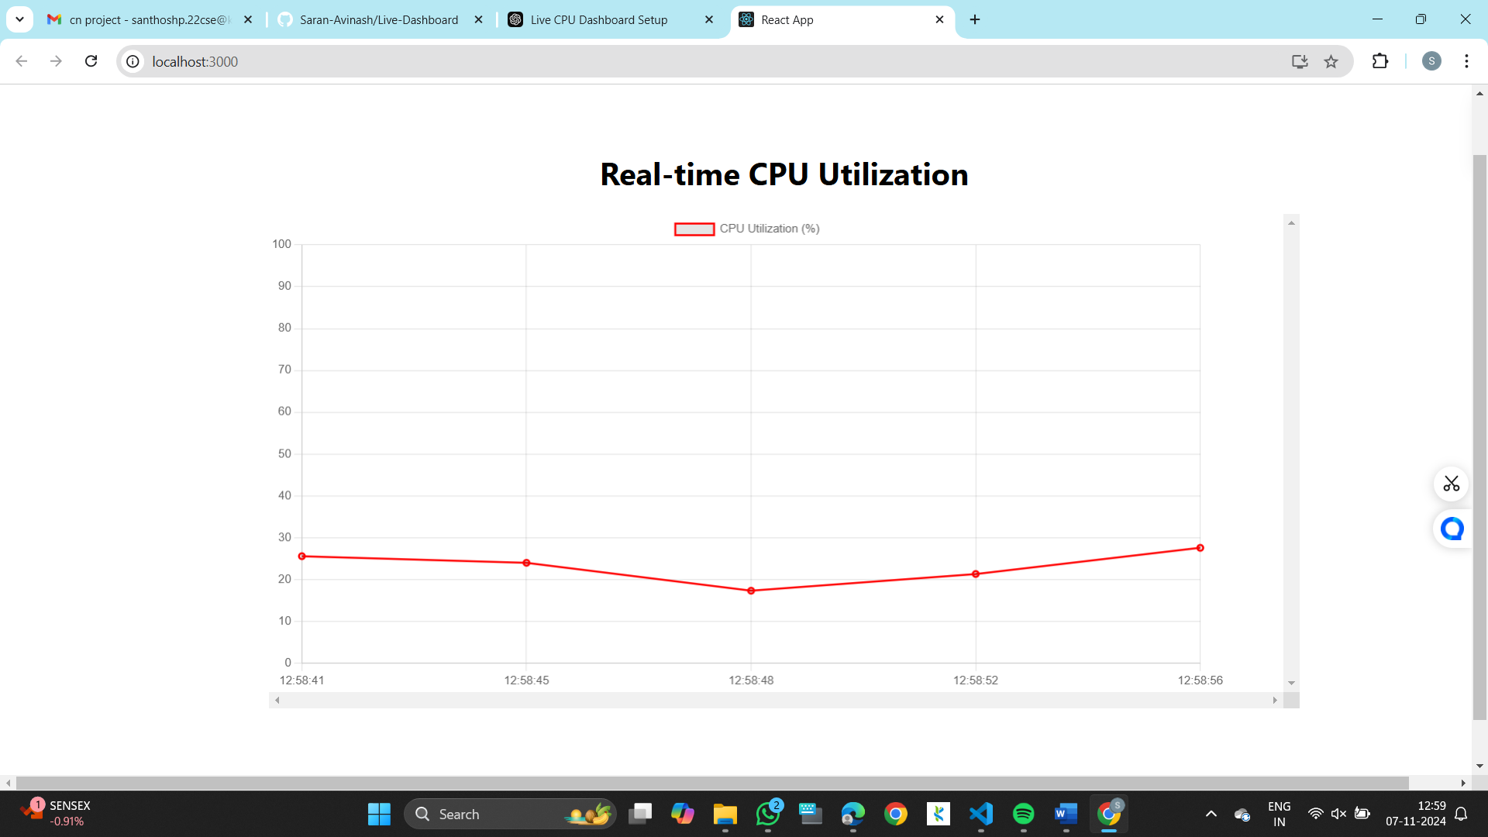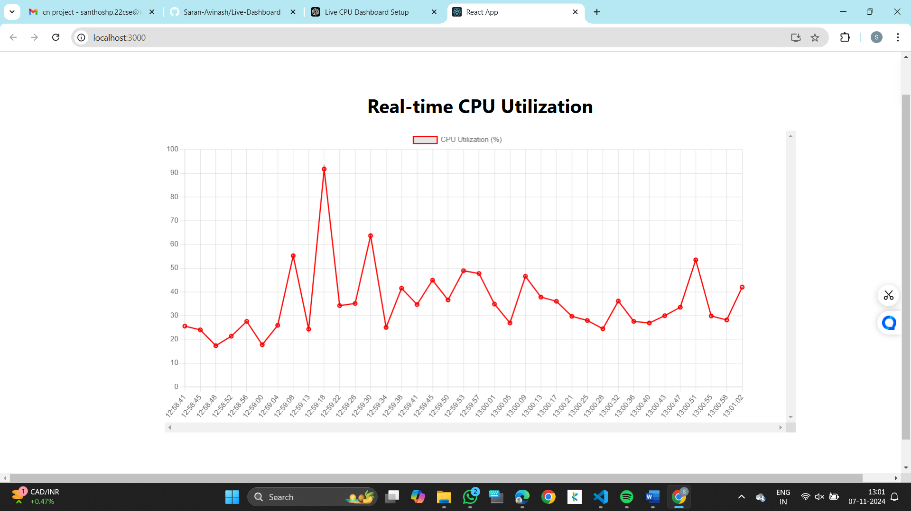

Conclusion

The Real-Time CPU Utilization Dashboard leverages WebSocket technology to provide continuous, real-time updates on CPU performance. By using React, Chart.js, Node.js, and PowerShell, the project offers an efficient and interactive monitoring solution that allows users to track system performance dynamically. The integration of WebSocket ensures real-time, low-latency data transmission, making the dashboard ideal for system administrators and users seeking to monitor their systems continuously.

Reference

https://github.com/Saran-Avinash/Live-Dashboard
https://socket.io/docs/v4/

